LAB TASK 10  
  
1. (a) Write a program in assembly language to print the numbers from 0 to 9.  
CODE:  
.model small

.stack 100h

.data

newline db 13, 10, '$' ; Carriage return and line feed

.code

main proc

mov ax, @data ; Initialize data segment

mov ds, ax

mov cx, 10 ; Set up a counter to loop 10 times (for numbers 0-9)

mov dl, '0' ; ASCII code for '0'

print_loop:

; Print the character in DL

mov ah, 02h ; DOS function to output a character

int 21h ; Call DOS interrupt

; Increment DL to get the next character

inc dl

; Loop until CX reaches 0

loop print_loop

; Print newline after the numbers

mov ah, 09h ; DOS function to output a string

lea dx, newline ; Load address of newline string

int 21h ; Call DOS interrupt

; Exit the program

mov ah, 4Ch ; DOS function to exit

int 21h ; Call DOS interrupt

main endp

end main

OUTPUT:::

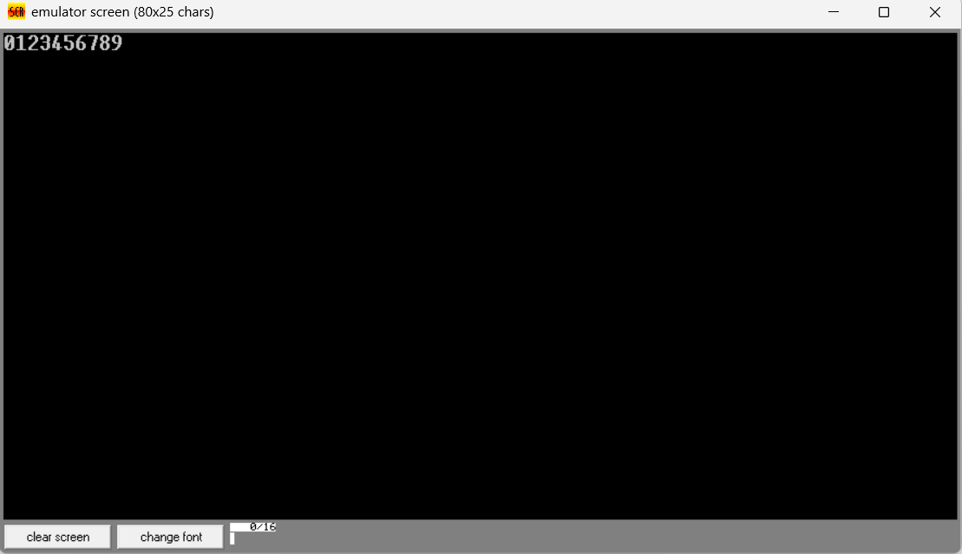  
(b) Write an assembly language program to print the characters from A to Z in reverse order.  
CODE:  
.model small

.stack 100h

.data

newline db 13, 10, '$' ; Carriage return and line feed

.code

main proc

mov ax, @data ; Initialize data segment

mov ds, ax

mov cx, 26 ; Set up a counter for 26 characters (Z to A)

mov dl, 'Z' ; ASCII code for 'Z'

print_loop:

; Print the character in DL

mov ah, 02h ; DOS function to output a character

int 21h ; Call DOS interrupt

; Decrement DL to get the previous character

dec dl

; Loop until CX reaches 0

loop print_loop

; Print newline after the characters

mov ah, 09h ; DOS function to output a string

lea dx, newline ; Load address of newline string

int 21h ; Call DOS interrupt

; Exit the program

mov ah, 4Ch ; DOS function to exit

int 21h ; Call DOS interrupt

main endp

end main

OUTPUT::::  
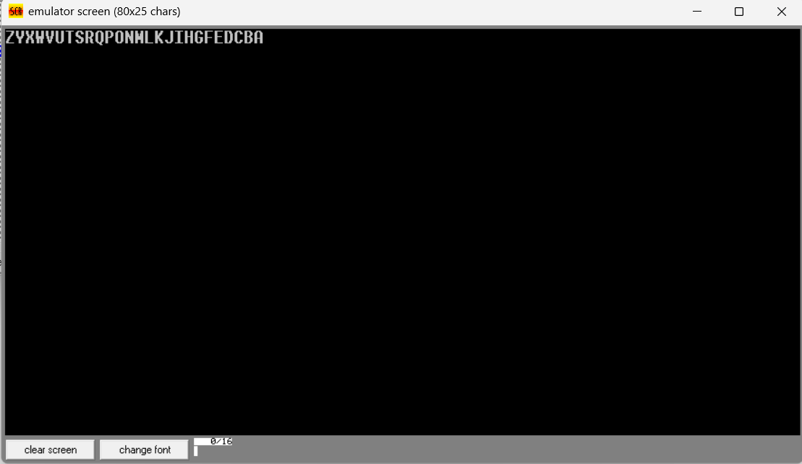

2. (a) Write a program in assembly language to print the numbers from 0 to 9 in reverse order.  
CODE:.model small

.stack 100h

.data

newline db 13, 10, '$' ; Carriage return and line feed

.code

main proc

mov ax, @data ; Initialize data segment

mov ds, ax

mov cx, 10 ; Set up a counter for 10 characters (9 to 0)

mov dl, '9' ; ASCII code for '9'

print_loop:

; Print the character in DL

mov ah, 02h ; DOS function to output a character

int 21h ; Call DOS interrupt

; Decrement DL to get the previous character

dec dl

; Loop until CX reaches 0

loop print_loop

; Print newline after the numbers

mov ah, 09h ; DOS function to output a string

lea dx, newline ; Load address of newline string

int 21h ; Call DOS interrupt

; Exit the program

mov ah, 4Ch ; DOS function to exit

int 21h ; Call DOS interrupt

main endp

end main

OUTPUT:::::  
  
  
  
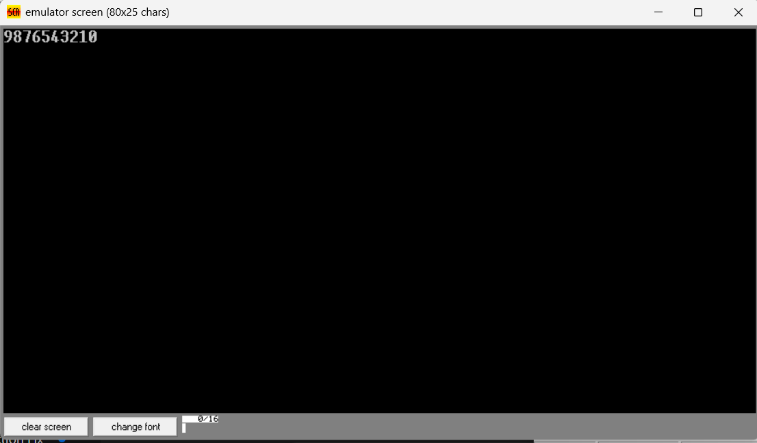  
(b) Write an assembly language program to print the characters from A to Z.  
CODE:  
.model small

.stack 100h

.data

newline db 13, 10, '$' ; Carriage return and line feed for new line

.code

main proc

mov ax, @data ; Initialize the data segment

mov ds, ax

mov al, 'A' ; Start with the ASCII code for 'A'

print_loop:

; Print the character in AL

mov dl, al ; Move the current character into DL for printing

mov ah, 02h ; DOS function to output a character

int 21h ; Call DOS interrupt to print the character

; Check if we've reached 'Z'

cmp al, 'Z' ; Compare AL with ASCII 'Z'

je end_print ; If equal, jump to end_print

; Move to the next character

inc al ; Increment AL to get the next character

jmp print_loop ; Repeat the loop

end_print:

; Print a newline after the characters

mov ah, 09h ; DOS function to output a string

lea dx, newline ; Load the address of the newline string

int 21h ; Call DOS interrupt to print newline

; Exit the program

mov ah, 4Ch ; DOS function to terminate the program

int 21h ; Call DOS interrupt to exit

main endp

end main

OUTPUT:::::  
